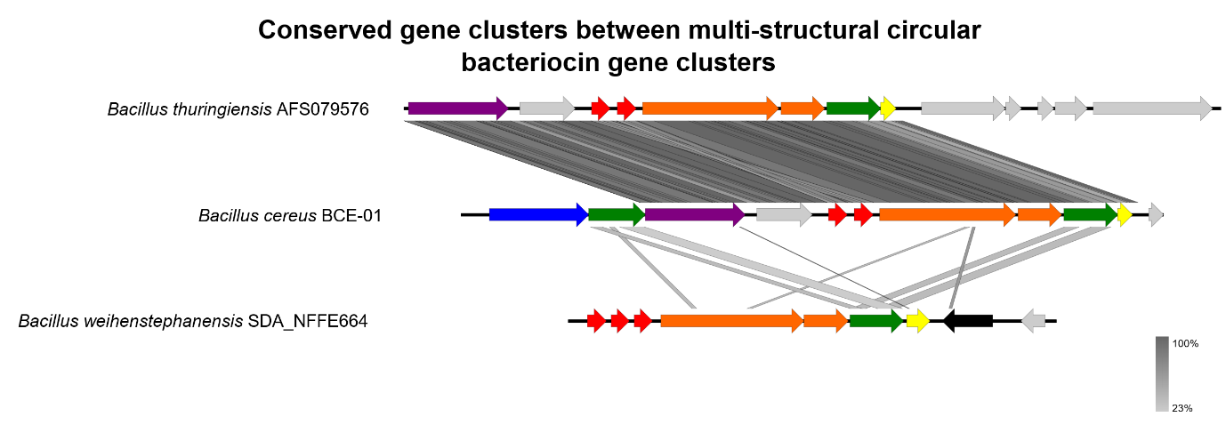
Fig S7: Multi-structural circular bacteriocin cluster
Diagram of circular bacteriocin gene clusters with multiple structural genes. Arrows show putative genes within the gene cluster. B. weihenstephanensis SDA_NFFE664 contains three structural genes spaced with independent promoters, while B. cereus BCE-01 and B. thuringiensis AFS079576 contain two. Red shows bacteriocin structural genes. Orange shows putative membrane proteins/stage II sporulation protein M. Yellow shows putative immunity. Green shows putative ABC-transporter proteins. Blue shows HylD/efflux RND transporters. Purple shows ABC-II/FtsX permeases. Black shows mobile genetic elements such as phage proteins/transposons/IS elements. Grey shows genes of unknown function which may or may not be related to circular bacteriocin production. Figure produced in Easyfig and Inkscape.

